INFORMED CONSENT TO OSTEOPATHIC MANUAL TREATMENT

I understand that the Osteopathic Manual Therapist is providing osteopathic manual therapy services within their scope of practice.

I hereby consent to my Osteopathic Manual Therapist to treat me with Osteopathic manual therapy for the above noted purposes including such assessments, examinations and techniques, which may be recommended by my Osteopathic Manual Therapist.

I acknowledge that the Osteopathic Manual Therapist is not a physician and does not diagnose illness or disease or any other physical or mental disorder. I clearly understand that osteopathic manual therapy is not a substitute for a medical examination. It is recommended that I attend my personal physician for any ailments that I may be experiencing. I acknowledge that no assurance or guarantee has been provided to me as to the results of the treatment. I acknowledge that with any treatment there can be risks and those risks have been explained to me and I assume those risks.

I acknowledge and understand that the Osteopathic Manual Therapist must be fully aware of my existing medical conditions. I have completed my medical history form as provided by my Osteopathic Manual Therapist and have disclosed to the Osteopathic Manual Therapist all of those medical conditions affecting me. It is my responsibility to keep the Massage Therapist updated on my medical history. The information I have provided is true and complete to the best of my knowledge.

I authorize my Osteopathic Manual Therapist to release or obtain information pertaining to my conditions(s) and/or treatment to/from my other caregivers or third party payers.

I have read the above noted consent and I have had the opportunity to question the contents and my therapy. By signing this form, I confirm my consent and I have had the opportunity to question the contents and my therapy. By signing this form, I confirm my consent to treatment and intend this consent to cover the treatment discussed with me and such additional treatments as proposed by my Massage Therapist from time to time, to deal with my physical conditions and for which I have sought treatment. I understand that at any time I may withdraw my consent and treatment will be stopped.

__________________________ _____________________________
Patient Printed Name Signature of Patient / Guardian

__________________________ _____________________________
Osteopathic Manual Therapist Date Signed

Name: ______________________________________ Birth Date_____________ Date_____________________
Address:________________________________ ___________________________________________________
City Province Postal Code
Home Phone: (____)_____________Work (____)________________Ext_______Cell (_____)_______________
Occupation/Work________________________________________________________________
CONTACT IN CASE OF EMERGENCY: _______________________________ Relationship_______________
Home Phone: (____)_____________Work (____)________________Ext_______Cell (_____)_______________
Whom may we thank for referring you?__________________________________________
Email address: _______________________________ Would you like to receive our newsletter via email? Yes/no

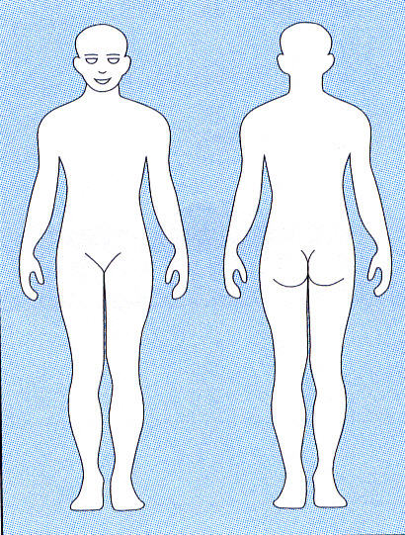
Reason for Visit_____________________________________________________________
When did your symptoms appear?______________________________________________
Is this condition getting progressively worse? □ Yes □ No □ Unknown
Mark an X on the picture where you continue to have pain, numbness, tingling, discomfort
Rate the severity of your pain on a scale from 1 (least pain) to 10 (severe pain) __________
Type of pain: □ Sharp □ Dull □ Throbbing □ Numbness □ Aching □ Shooting □ Burning □ Tingling □ Cramps □ Stiffness □ Swelling □ Other
How often do you have this pain?_______________________________________________
Is it constant or does it come and go?_____________________________________________________________
Activities or movements that are painful to perform □Sitting □Standing □Walking □Bending □Lying Down
Does it interfere with your □ Work □ Sleep □ Daily Routine □ Recreation

What treatment have you already received for your condition? □ Medications □ Surgery □ Physical Therapy
□ Chiropractic Services □ Massage Therapy □ None □ Other _____________________________________

Exercise: □ None □ Moderate □ Daily □ Heavy
Work Activity: □ Sitting □ Standing □ Light Labour □ Heavy Labour □ Mixed
Habits: □ Smoking Packs/day: _____ □ Alcohol Drinks/Week: _____
□ Coffee/Caffeine Cups/Day: _____ □ High Stress Level Reason_________________

Injuries/Surgeries Description Date
Falls _____________________________________________________________________ _________________
Head Injuries_______________________________________________________________ _________________
Broken Bones______________________________________________________________ _________________
Surgeries__________________________________________________________________ _________________
Birth Trauma/Injury__________________________________________________________ _________________
Do you have any pins or plates? _________ If yes, where? ____________________________________________

Medication(s) Allergies Vitamins/Herbs/Minerals
___________________ ___________________ ___________________
___________________ ___________________ ___________________
____________________ ___________________ ___________________
____________________ ___________________ ___________________

